Writtle University College
Further Education Candidate Registration & Certification Policy
Updated 27th September 2020

September 2020- Update

This Policy covers procedural requirements for Further Education Candidate Registration and Certification.
In these extraordinary times, any variations to procedures will be issued by our Awarding Bodies and the Department for Education. WUC recognises this may include revisions to assessment procedures and examination requirements, in the context of COVID-19.
At present, this document should be read in conjunction with:
- Joint Council for Qualifications: Instructions for conducting examinations, 1st September 2020 to 31st August 2021, and

- WUC Invigilation Handbook, dated 23rd September 2020.

- Awarding Body Registration – Cross-functional responsibilities for student registration with the awarding body (excludes GCSE/FS

Any changes to this Policy will be identified by the Director of Further Education or the FE Quality Manager.
If there are any administrative or procedural queries related to this Policy, please first contact Leigh Arnold, Examinations Officer.
Contents
Introduction………………………………………………….. | ………………………………………………………………………………. | 3
Scope of Policy……………………………………………… | ……………………………………………………………………………… | 3
Initial Learner Registration…………………………… | ………………………………………………………………………………. | 4
Procedure for late, inaccurate or false registrations…………………………………………………. | ………………………………………………………………………………. | 4
Registering Achievement……………………………… | ………………………………………………………………………………. | 4
WUC process for minimising and Managing errors……………………………………………………………. | ………………………………………………………………………………. | 5
Audit of certification checks…………………………. | ………………………………………………………………………………. | 5
Schedule………………………………………………………. | ……………………………………………………………………………… | 6
Appendix 1 – Bulk Registration Processes……. | - City & Guilds………………………………. | 8
 | - Pearson Edexcel…………………………… | 9
 | - NCFE………………………………………. | 10
Appendix 2 – Individual Registration Processes……………………………………………………. | - City & Guilds (Individual Registrations)…... | 11
 | - Pearson Edexcel (Individual Registrations)... | 13
 | - NCFE (Individual Registrations)…………... | 16
Appendix 3 – Registering Achievement…………. | - City & Guilds……………………………… | 18
 | - Pearson Edexcel…………………………… | 19
 | - NCFE ……………………………………... | 20
Appendix 4 – Amendments and Queries………. | ……………………………………………………………………………… | 21
Appendix 5 – Certificate Postage………………….. | .................................................................................. | 22

Appendices

Appendix 1 Bulk Registration Processes

Appendix 2 Individual Registration Processes

Appendix 3 Registering Achievement

Appendix 4 Amendments and Queries

Appendix 5 Certificates are sent by first class post.

Document Control Box
Policy / Procedure Title |  | Further Education Candidate Registration & Certification Policy
Date last approved |  | 30 November 2020  18/02/21
Next review |  | 1 April 2021
Policy owner |  | FE Quality, Admissions and MIS
Approving |  | Director of Further Education, Vice Chancellor, UCLG *
Status |  | Active
Original Document Published |  | May 2012
*UCLG is the University College Leadership Group

Related documents, procedures and legislation and links to relevant awarding body websites | Writtle University College - Centre registration number: 016355  City and Guilds https://www.walled-garden.com/login  Edexcel (Pearson) https://www.edexcelonline.com/Account/Login.aspx  NCFE http://www.ncfe.org.uk/

Introduction

As part of WUC’s commitment to quality assuring standards we aim to ensure that any regulatory requirements of awarding bodies are met.

We review all our policies annually or in response to regulatory changes to ensure that they remain fit for purpose.

Scope of policy

This policy applies to all regulated qualifications offered by a number of different awarding bodies

Initial Learner Registration

WUC aims to register all learners within 42 days of the learners commencing their full time programme or 14 days of the learners commencing their part time programme. Learner registration must be completed by the exams officer using information provided by course managers and the MIS / Columbus Unit E data bases.

Functional skills registration should occur within 42 days of the learners commencing their Functional Skills programme. This will ensure learners do not undergo assessment prior to their registration.

The FE Awarding Body Registrations folder is accessible to all curriculum staff. Curriculum staff are responsible for initially checking the registrations. Further to this, the Admissions team carry out audits of registrations at various points through the academic year.
A copy of the ‘Awarding Body Registration – Cross-functional responsibilities for student registration with the awarding body (excludes GCSE/FS)’ can be found as an attached document.

Procedure for late, inaccurate or false registrations

In the event of late, inaccurate or false registrations, the awarding body late registration rules would be referred to. Late registration rules can be found on the awarding body websites.

Where Writtle University College have failed to register a learner on a programme before the operational end date, the learner would be registered on a replacement qualification or a suitable alternative that meets the learner’s needs. However, if the learner would be considerably disadvantaged by being registered on to an alternative qualification, an application for late registration along with sufficient evidence would be submitted to the awarding body for consideration.
We make every effort to ensure accurate and timely registrations, however, any inaccurate or false registrations will be identified during our auditing process. Amendments, transfers or withdrawals will be processed online through the awarding body websites. If the online option isn’t viable, the awarding body will be contacted directly via email.

Registering Achievement
All Learners must be registered on the qualification before a claim for certification can be claimed. For Functional Skills, all students must be registered before an assessment is undertaken. Following confirmation from the Awards Boards (held in late June-July) or receipt of Work based Achievement Reports (WBARs). The results for the students enrolled on each course are passed to the Examinations Officer along with their module grades and overall grade (Pass/Merit/Distinction) via either a printout from ProMonitor or via a spreadsheet of results in the case of Functional skills.

The Exams officer will export the data to the awarding body share points as required. A second exams officer or quality officer will check all marks were exported correctly from the Pro Monitor or spreadsheet before confirming final grades can be sent / exported.
N.B. The judgement on learners’ work remain provisional until verified by the awarding body.

Amendments and Queries

City & Guilds
Email City & Guilds via the Customer Services email address centresupport@cityandguilds.com who will advise accordingly.
Pearson Edexcel
- If a unit has been reported incorrectly, an email authorising the change together with amended final awards boards minutes should be submitted to Registry
- Processing queries raised by Pearson Edexcel can be located on Pearson Edexcel Online https://www.edexcelonline.com/Account/Login.aspx

These queries will be directed to the relevant Course Manager and a copy held by the Examinations Officer to monitor quality. The Course Manager is to respond to the Examinations Officer who will keep a progress check, log details of the query and amend results on Pearson Edexcel Online and reply to the query online.

NCFE
Email our NCFE Customer Support Assistant (CSA), Danielle Avery via email danielleavery@ncfe.org.uk who will advise accordingly.

WUC Process for Minimising and Managing Errors
All learners are registered electronically via the awarding body websites. Please refer to the awarding body processes in the appendices. This will reduce the likelihood of human errors. Once learners are registered, copies of all learner registrations are saved on WUC’s secured network that complies with GDPR rules. All course Managers are required to check the details of learner registrations regularly in order that mistakes can quickly be rectified.

Issue of Certificates
Certificates are posted by first class post. On occasions they are returned by the Post Office marked ‘not called for’ or ‘no answer’ etc.
If a returned certificate arrives in Registry follow the procedures below:
- Contact the student by phone or email
  - If the student supplies new address please forward the certificate update Unite with their new address and complete the Enrolment Event
  - If the student is unobtainable record in Unite Enrolment Event that the certificate has been returned and filed in the ‘Returned Certificates’ filing cabinet.

Audit & Verification checks
An audit of registrations take place both in October and February, following the bulk registration process. This is carried out by FE Admissions. Course Managers also take responsibility for checking that all students are registered correctly prior to assessments taking place.
Student awarding body registrations are held on G/data/FE Awarding Body Registrations
Evidence against enrolment files, Learning Agreement/Enrolment Forms.
Course lists drawn from UNIT-e Columbus, crossed checked against enrolments and registrations.
See Awarding Body Registration | Cross-functional responsibilities for student registration with the awarding body.

Schedule
[March]
Course Confirmation forms given to Course Managers for review.
[April]
Course Managers return Course Confirmation forms which will notify Registry of any change in learning aim, units or awarding body. FE Central to authorise all changes.
[April]
Registry checks the LARA database that all aims are valid and fundable (where applicable). Out of date learning aims are to be brought to the attention of Course Managers and FE Central.
[May]
Registry to update curriculum held on UNIT-e.
[Aug/Sept]
Main enrolment takes place. Awarding body and learning aim information held at curriculum level will be automatically copied to the student level during enrolment.
[Oct] Autumn Enrolment and course changes complete.
Bulk registration of NCFE, City & Guilds and EDEXCEL candidates by the Examinations Officer (no later than one month from initial enrolment of the candidate with the College, depending on the length of the programme)
RHS candidates registered by the Examinations Officer. Practical within one month of starting their course. Examinations upon receipt of payment from the candidate.
F/S registrations are to made within one month of starting their course. This includes both study programme students and Apprentices.
[Early November]
Registration documentation given to Internal Verifier for confirmation.
[Mid-November]
Registry to check that all enrolments are registered with the relevant awarding bodies.
Note: Enrolments entered onto UNIT-e after the bulk registration has taken place (this would include the F/S registrations) are registered with the awarding bodies on an individual basis by the Examinations Officer. Registration documentation sent to Internal Verifier for confirmation.
[July] Confirmation of Achievement data provided by curriculum staff via the ProMonitor system for vocational qualifications, and via a local spreadsheet that records all Functional skill achievement. The Examinations Officer updates information on awarding body websites and claims the related certificates.
[August-September] The Examinations Officer to update achievement data on UNIT-e and issue result slips/certificates to the student’s home address unless informed otherwise. (For example, Veterinary Nursing certificates are issued to the Veterinary Nursing department)

Appendix 1

Bulk Registration Processes

CITY & GUILDS
Synopsis of City & Guilds bulk registration process:
Using the Toad application extract all of the City & Guilds flagged enrolments that have a status of Live or Provisional with an associated Course Year enrolment record that falls between 01/08/ and 31/07/. Export this data as a .csv file.
City & Guilds have provided an Excel based data import process that converts candidate information in .csv format into the .dat format required by the City & Guilds upload system. The system also validates the data and provides an error output.
Once the errors have been resolved in the import file the C&G Electronic Entry Form will produce a .dat file which can be uploaded to City & Guilds via their website.
Registration confirmation documents are attached to the enrolment files and copies forwarded to the Internal Verifier for confirmation and notification of any amendments, if applicable.

Detailed City & Guilds Bulk Registration Process:
Open Toad for Oracle version 11.7 (or higher) ensuring that you have full administrator rights.
Navigate to G:\DATA\REGISTRY\PROCEDURES\Registry & Admissions Procedures\Registration - Conferment, Awards Boards and Certification\City & Guilds\Bulk Registration Data and open the SQL script: CityAndGuilds_Named_Registration_2015.SQL.
Check that start and end date parameters apply to the current academic year.
Click ‘Run’ (Outlined in red below)
Right Click on data extracted by the query and select the ‘Export Dataset…’ option.
Navigate to G:\DATA\REGISTRY\PROCEDURES\Registry & Admissions Procedures\Registration - Conferment, Awards Boards and Certification\City & Guilds\Bulk Registration Data and open the C&G Electronic Entry Form and import the .csv file produced by Toad.
Click on the cell marked ‘Clear Saved Data’. Then click on the cell marked ‘Import Data’.
In the subsequent window click on the button marked ‘’Find File’ and navigate to the .csv file. In the drop down menu marked ‘Worksheet’ select ‘Data’, then click ‘Continue’.
In the next window enter 1 into ‘Column Headers’ and 2 into ‘First Row of Data’.
The Data Import Wizard will now open. Click on the button marked ‘Load Default Mapping’. The wizard should now look like this (manually adjust if it does not):
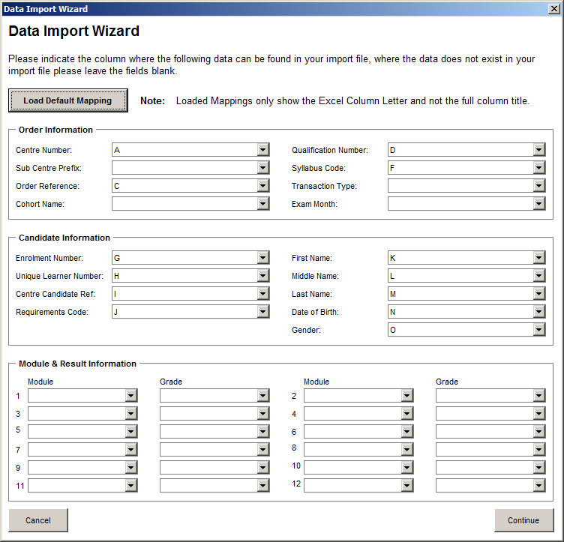
Click ‘Continue’ and in the next window select ‘Named Registration’ in the ‘Transaction Type’ drop down list and click ‘Continue’. The data from the .csv file will now be imported into C&G Electronic Entry Form.
Click on the cell marked ‘Create EDI File’.
Any rows of data that are missing information (e.g. ULN numbers) or have incorrectly formatted dates will be highlighted in the error output tab. These errors must be corrected in the source .csv file and then re-imported into the C&G Electronic Entry Form. Once the import file is error free the software will produce a .dat file.
Log in to the City & Guilds website and navigate to the Registration Upload page.
Select ‘Upload Candidates’ and navigate to where the .dat file is stored. Select file and click ok.
Depending on the file size the website may take some minutes to upload and process the data, it also validates the data and will provide a basic error description and row number of the error. The row number will correspond with the same row in the .csv import file. The error must be corrected on this file processed through the C&G Electronic Entry Form and a new .dat file created and uploaded to the website.
Note: City & Guilds candidates are registered on the level of qualification, not the type, (Level = 1,2 or 3) (Type = award, certificate or diploma) so registering a candidate for an award in photography will mean the candidate is still registered if they wish to progress to a diploma in photography. The City & Guilds online system will treat duplicate enrolments as errors to be removed from the upload file.
Once a file is successfully uploaded the website will take an amount of time to confirm registration. Once confirmed the .pdf documents with candidate’s names, reference numbers and the qualifications they are registered on can be printed and saved. The .csv file produced by the Toad query includes a shortened form of each enrolment’s course code enabling separate registration documents to be saved for each course.
Copies of the student registration documents are passed to the Internal Verifier for confirmation.

EDEXCEL
Synopsis of Edexcel bulk registration process:
Using the Toad application extract all of the Edexcel flagged enrolments that have a status of Live or Provisional with an associated Course Year enrolment record that falls between 01/08/17 and 31/07/18 for example. Export this data as a .csv file.
Divide the .csv file into courses and upload each file to the Edexcel website. Once any errors in the upload are corrected registration confirmation documents can be printed and saved.
Registration confirmation documents are attached to the enrolment files and copies forwarded to the Internal Verifier for confirmation and notification of any amendments, if applicable.

Detailed Edexcel Bulk Registration Process:
Open Toad for Oracle version 11.7 (or higher) ensuring that you have full administrator rights.
Navigate to G:\DATA\REGISTRY\PROCEDURES\Registry & Admissions Procedures\Registration - Conferment, Awards Boards and Certification\EDEXCEL BTEC Registering\Bulk Registration Data and open the SQL script Edexcel_Named_Registration_2015.SQL.
Check that start and end date parameters apply to the current academic year.
Click ‘Run’ (Outlined in red below)
Right Click on data extracted by the query and select the ‘Export Dataset…’ option.
Because each batch must be for the same qualification the .csv file must be separated into courses. Column M (titled ‘E_REFERENCE’) contains each enrolments course reference.
Log into the Edexcel website and navigate to the Candidate Registration section.
Select ‘Register BTEC Candidates’.
From the Drop Down list select the qualification that matches the cohort you are uploading.
Select ‘Upload batch file’ and navigate to the .csv file you wish to upload.
The website performs a validation on the data and will highlight any missing or incorrectly formatted cells. These errors can either be corrected on screen or on the .csv file though the latter option will require the upload process to be restarted.
An error free upload will produce the registration documents which are then printed and saved.
Copies of the student registration documents are passed to the Internal Verifier for confirmation.

NCFE
Synopsis of NCFE bulk registration process:
Using the Toad application extract all of the NCFE flagged enrolments that have a status of Live or Provisional with an associated Course Year enrolment record that falls between 01/08/15 and 31/07/15. Export this data as a .csv file.
Divide the .csv file into courses and upload each file to the NCFE website. Once any errors in the upload are corrected registration confirmation documents can be printed and saved.
Registration confirmation documents are attached to the enrolment files and copies forwarded to the Internal Verifier for confirmation and notification of any amendments, if applicable.

Detailed NCFE Bulk Registration Process:
Open Toad for Oracle version 11.7 (or higher) ensuring that you have full administrator rights.
Navigate to G:\DATA\REGISTRY\PROCEDURES\Registry & Admissions Procedures\Registration - Conferment, Awards Boards and Certification\NCFE\NCFE Bulk Registration Data and open the SQL script NCFE Named Registration 2015.sql.
Check that start and end date parameters apply to the current academic year.
Click ‘Run’ (Outlined in red below)
Right Click on data extracted by the query and select the ‘Export Dataset…’ option.
Right Click on data extracted by the query and select the ‘export as csv’ option.
Because each batch must be for the same qualification the .csv file must be separated into courses. Column A (Title ‘Course Reference’) contains each enrolments course reference.
Log into the NCFE website and navigate to the Register Candidates section.
Using the search facility find the qualification for the cohort you wish to register.
Note: NCFE use Learning Aims to identify their qualifications but in a particular format. For example 80026745 is held in the NCFE system as 8002/674/5.
On the following page select ‘Upload Batch Candidates’ and navigate to the relevant .csv file.
The website will validate the data and highlight any cells incorrectly formatted or have missing data. These errors can be corrected on screen or by amending the .csv file and re-uploading.
An error free file will generate the candidate registration documents.

Appendix 2

Individual Registration Processes

City & Guilds (Individual Registration)
In-year starts, roll-on roll-off programmes. Consider the length of programme less than one week, for example, ‘awards’ which need immediate registration.
Login on Walled Garden City & Guilds website: https://www.walled-garden.com/login
Before registering candidates it is suggested that the FE Quick Guide is referred to.

Click on Catalogue

Enter the City & Guilds qualification code eg. 0067-21
Click Go
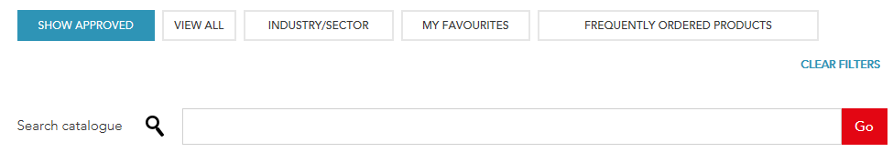

Click Place an order
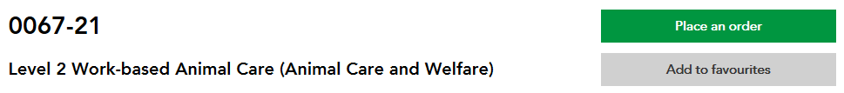

Click Named registration
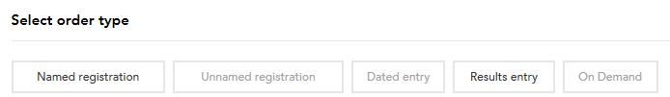

Click on Add new candidate, unless you know a student has been previous registered, in which case you are able to search by clicking on Candidate details or by selecting Enrolment Number if this is known. For the purpose of this document, we will continue with the Add new candidate option.
- Enter First name
- Enter Middle name as appropriate
- Enter Last Name
- Enter Gender
- Enter DOB
- Enter the students Writtle University College Student ID under Your Reference
Click Add new candidate
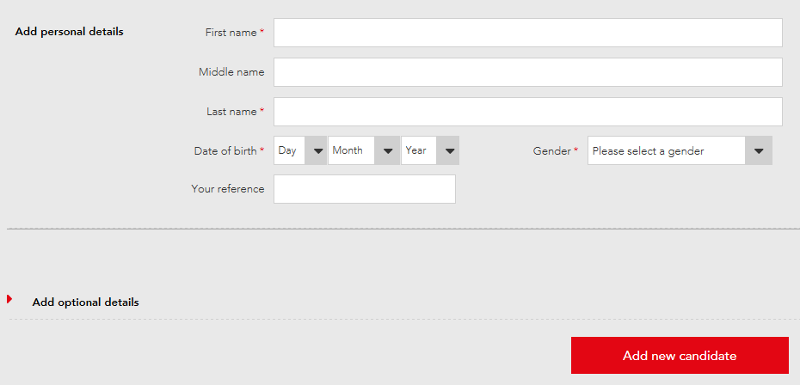

These entries will appear in the lower part of the screen
Check details
The following window will appear, select as appropriate
Scroll down and check candidate information before clicking on View Basket
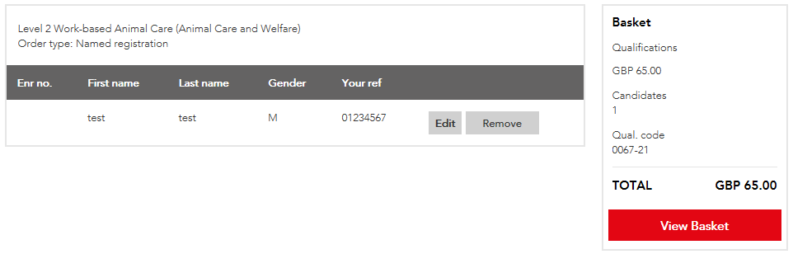
It is advised to create a cohort when prompted (Use the WUC Course Reference)
Click Continue
Click Continue
Enter subject area as the Purchase Order Number (For this example ‘Animal’)
Click Submit Order
When prompted, enter the email address of the member of Admissions who requested the registration.

To save an update registration listing:
Click on Reports
Click on Candidate results

Select Registration Listing from the Show me drop down list
- Enter Qualification code eg. 0067-21
- Select or since check button and select September as the month and the year in which the current academic year started
Click Search
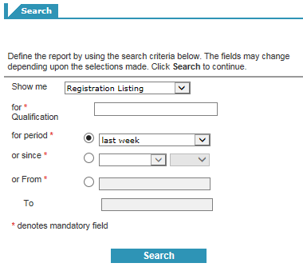
Click Print a Registration Listing to PDF
Print to PDF
Save to G-drive, for this example:
G:\DATA\FE Awarding Body Registrations\Animal\City & Guilds
Save as, for example:
AS0101PWD2^16 AS0261PDP2^16 0067-21 NPTC Lvl 2 Dip WB Animal Care Animal Care & Welfare Reg Listing

Pearson Edexcel (Individual Registration)
Further guidance can be found at the following link:
https://qualifications.pearson.com/en/support/support-topics/registrations-and-entries/vocational-registrations.html/EO#tab-UsingEdexcelOnline
Go to Pearson Edexcel Online https://www.edexcelonline.com/Account/Login.aspx
Log in
Select the required qualification from the Select Qualification drop down list (For example BTEC)
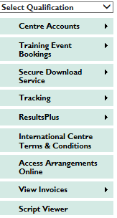

Select Candidates
Select Register Candidate
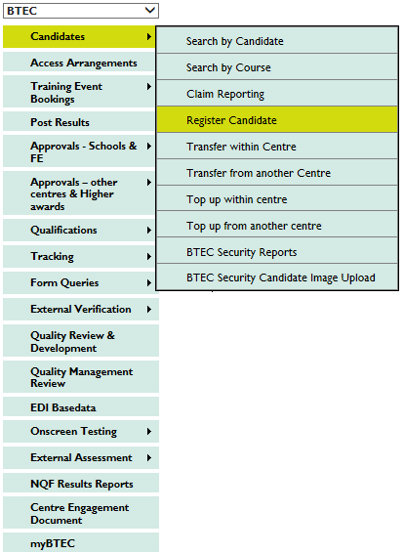
Select Full Award
Select correct enrolment date
Enter Order Number (Advised to use Subject area eg Sport)
Ensure ‘No’ is checked against SRFs required?
Tick the confirmation box
Click Next
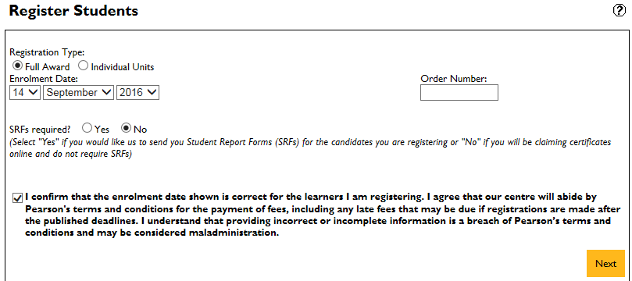
Select required programme
Click Next
Click Register Online

- Enter the students Writtle University College Student ID under Centre Reference
- Enter First Name
- Enter Last Name
- Check Male of Female check box
- Enter Date Birth
- Enter Planned Completion (dd/mm/yyy)
- Enter Study Mode (Not required for all qualifications)
- Enter Combination (Not required for all qualifications)
- Enter students ULN
Click Add
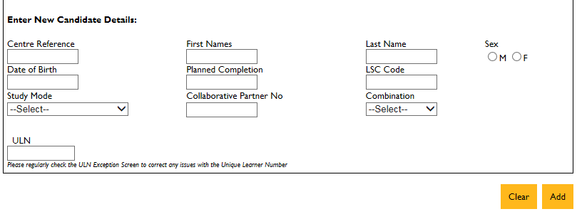

These entries will appear in the lower part of the screen
Check details
Click Register
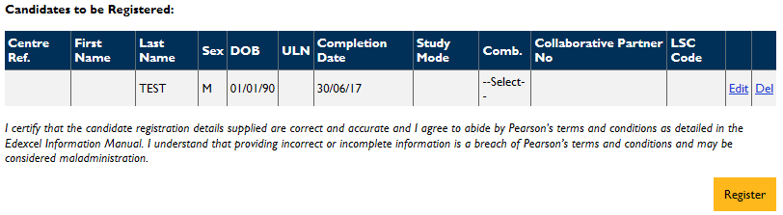

Click Confirmation Report
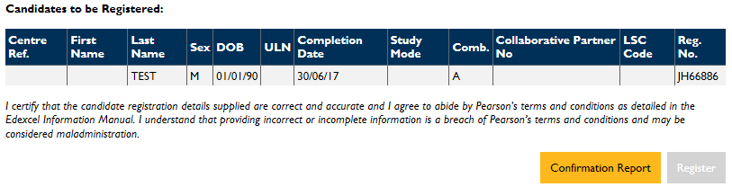
Print a copy of the Confirmation Report to PDF
Save to G-drive, for this example:
G:\DATA\FE Awarding Body Registrations\Sport\Pearson
Save as, for example:
SP0031FDP2^16 JMW57 Lvl 2 Dip Sport 10.10.16

Change of details can now be updated online. Choose BTEC from home page, then Candidates and Candidate details. Search for student and update details as required.
Transfers, Top ups & Unit registration can also be done online.
Certification can also be claimed on line. Search for student as above and follow instructions on screen.
Withdrawals MUST BE NOTIFIED IN WRITING to Edexcel BY 31ST January for a refund in fees

NCFE (Individual Registration)
To register for the first time go to www.ncfe.org.uk and click on “The Portal” and Login
Although you won’t be able to register candidates unless you have approval for a programme, you can “bank” candidates. This means that when your centre’s approval to offer the programme, we’ll register the candidates that you’ve already banked for you and let you know when we’ve done this. Please contact your Centre Support Assistant if you’d like more information.

You can cancel the registration process any time provided you haven't finished the final Verification step.

If you need any help when registering your candidates, please contact your Centre Support Assistant

Click Register my learners
Enter the qualification subject (For example, Photography)
Select the required qualification from the drop down list (for example NCFE Level 1 Award in Photography)
Select the current academic year from the Available Session drop down list
Check Add to existing batch box if required
- Enter Forename
- Enter Middle name as appropriate
- Enter Surname
- Enter the students Writtle University College Student ID under Centre Learner Ref
- Enter DOB
- Enter Ethnicity (If known)
- Enter Gender
Click Add to add more students or
Click Next

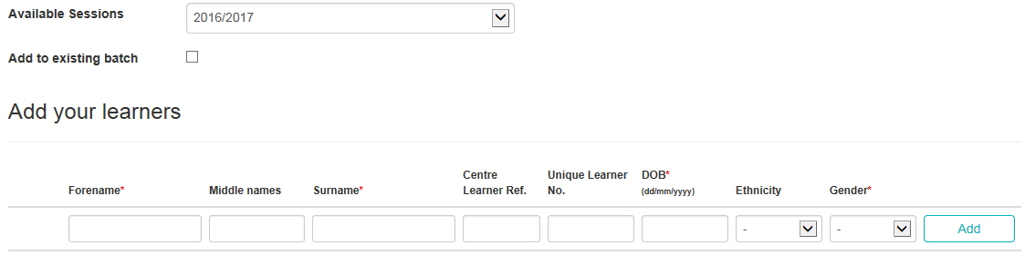
- Enter Your reference number
- Enter a Purchase Order number
Click Finish

Print a copy of the Candidate Status to PDF
Save to G-drive, for this example:
G:\DATA\FE Awarding Body Registrations\Photography\NCFE
Save as, for example:
AD0024PCE1^16 NCFE Lvl 1 Award Photography Course Yr1 Reg Conf 12.10.16

The FE Awarding Body Registrations folder is accessible to all curriculum staff. Curriculum staff are responsible for checking the registrations initially. Further to this, the Admissions team carry out audits of registrations at various points through the academic year. Audit documents are saved to:
G:\DATA\FE Awarding Body Registrations\Audits\2017-2018
A copy of the ‘Awarding Body Registration – Cross-functional responsibilities for student registration with the awarding body (excludes GCSE/FS)’ can be found at Appendix I.

Appendix 3

Registering Achievement

City & Guilds Achievement
Following confirmation from the Awards Boards (held in late June-July) or receipt of Workbased Achievement Reports (WBARs). The results for the students enrolled on each course are passed to the Examinations Officer along with their module grades and overall grade (Pass/Merit/Distinction) via a printout from ProMonitor. In the case of Functional skills achievement, the confirmation of achievement must be sent to exams by the English & Maths CTL. The CTL must confirm unit and specification code to ensure the correct level of Functional skills is claimed.
Certificates can be claimed on Walled Garden:
Log in to the City & Guilds website (Walled Garden)
Click Catalogue
Enter the relevant Product code eg. 0067-21
Click Go
Select the qualification listed
Click Place an order
Click Result Entry
Tick required unit codes and certification module code
Click Continue
Select either Candidate details, Cohort or Enrolment number from the Search existing candidates by drop down list, depending on what details you have
Tick the Add box next to the student
Click Add To Order
Click Continue
Enter the required grades from the drop down lists next to each unit number
Click continue
You can print a confirmation list and an order reference number will then be provided

Pearson Edexcel Achievement
Following confirmation from the Awards Boards (held in late June-July) or receipt of Work-based Achievement Reports (WBARs). The results for the students enrolled on each course are passed to the Examinations Officer along with their module grades and overall grade (Pass/Merit/Distinction) via a printout from ProMonitor.

As of academic year 20/17, Writtle University College no longer use SRFs. All claims are submitted to Pearson Edexcel directly through Pearson Edexcel Online by the Examinations Officer.
Awards boards are to confirm
- Programme title and number
- Combination
The combination must be correct; if it is different from the combination on which the student is currently registered you must contact the Examinations Officer. In such cases, you will need to check that all units, which are used for the award, are approved on the new combination and that the student is eligible. If you add a new combination or alter units without checking that they are correct, the claim will be rejected by Pearson Edexcel and returned under query, the query will also be logged with Quality Operations at Pearson Edexcel.
- Unit Grades
  - D – Distinction
  - M – Merit
  - P – Pass
  - U – Unclassified
  - T – Transferred credit*
- Overall Result
- Award Date (The month and year in which the student completed)
- Full Certificate/Fallback Certificate or Interim Certificate
  - Full Certificate – If the student has completed all required units and needs overall certification
  - Fallback Certificate - For use where the student has registered on the full qualification and does not intend to complete.
- Withdrawn Student

NB *Transferred credit – for use only where a student has transferred registration to a new programme at the same or another centre, previous success on these units has already been reported and you have received a transfer performance report confirming the grades. In all other instances, credit for previous student achievement must be assessed by APL.
To make a claim go to Pearson Edexcel Online https://www.edexcelonline.com/Account/Login.aspx
Login
Select BTEC
Select Candidates
Select Search by Candidate
Enter required details
Click next
A qualifications window will then appear
Click Details
Click Edit
Check Claim Type (Eg. Full Award, Interim or Fallback)
Check required grades against the relevant units
Enter an Award Date
Click Save

NCFE Achievement
Following confirmation from the Awards Boards (Held in Late June-July). The results for the students enrolled on each course are passed to the Examinations Officer along with completed Claim Forms.

Claims are made directly with NCFE via the NCFE Portal

To make a claim go to www.ncfe.org.uk and click on “The Portal” and Login
Select Certification
Click on Make a claim
Search for individual learner or batch
Check the box next to the required learner
Click Submit
Click in box under Claim
Select required outcome
Click on Achieved
Enter the name of the Internal Quality Assurer (IQA) and check the confirmation box

Appendix 4

Amendments and Queries

City & Guilds
Email City & Guilds via the Customer Services email address centresupport@cityandguilds.com who will advise accordingly.

Pearson Edexcel
- If a unit has been reported incorrectly, an email authorising the change together with amended final awards boards minutes should be submitted to Registry
- Processing queries raised by Pearson Edexcel can be located on Pearson Edexcel Online https://www.edexcelonline.com/Account/Login.aspx

Login
Select Qualification, for example, BTEC
Form Queries
Search Query
Enter Student Registration Number
Click Search

These queries will be directed to the relevant Course Manager and a copy held by the Examinations Officer to monitor quality. The Course Manager is to respond to the Examinations Officer who will keep a progress check, log details of the query and amend results on Pearson Edexcel Online and reply to the query online.

NCFE
Email our NCFE Customer Support Assistant (CSA), Danielle Avery via email danielleavery@ncfe.org.uk who will advise accordingly.

Appendix 5
Certificates are sent by first class post.
Instructions for updating Unit E Enrolment screens
TO NOTE: All veterinary nursing certificates, the originals, must be sent to the veterinary department for distribution to students. Copies retained in Registry. Follow the procedure below and reference the date and time that certificates were sent to the veterinary department. Evidence of certification to enable them to register their professional status with the RCVS.
1. Search for the student eg name or reference number.
2. Go to View - Enrolment HESA OR Tools enrolment browser. Choose the relevant course ie the course that matches the certificate that you are about to post. Ensure that you are on the course and not the year eg EDAGFTW^16 and not EDAGFTW^16^1.
3. Go to View – Enrolment Event. Go to the NEW icon in the menu to set up a new event.
Under the following headings enter these details:
Title: CERT SENT
Reference: CERT SENT
Type: from the pick list choose ‘Certificate Sent’
Start: enter the date you posted the certificate
Notes: add notes if you wish, could be used when a certificate is returned by the post office.
Staff: (bottom of screen) search for your name
Save

Procedure for dealing with a returned certificate / award

Certificates are posted by first class post. On occasions they are returned by the Post Office marked ‘not called for’ or ‘no answer’ etc.
If a returned certificate arrives in Registry follow the procedures below:
- Contact the student by phone or email
  - If the student supplies new address please forward the certificate update Unite with their new address and complete the Enrolment Event
  - If the student is unobtainable record in Unite Enrolment Event that the certificate has been returned and filed in the ‘Returned Certificates’ filing cabinet.

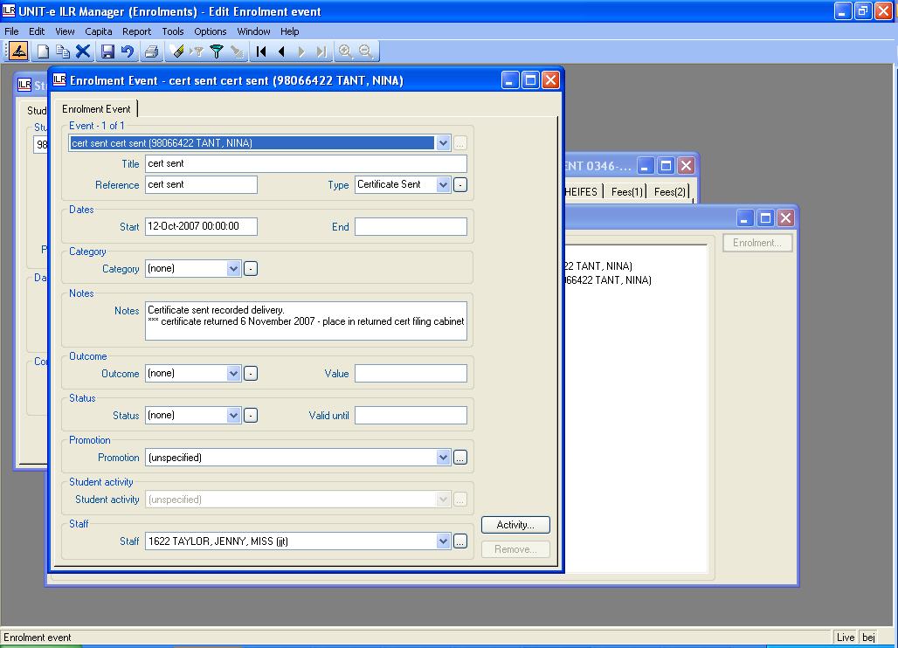

End

